CERTIFICATE OF ANALYSIS

Product Number: | CSP-1000
Description: | Calf spleen tissue prepared by acetone extraction.
Lot Number: | 6177
Appearance: | Powder

Assays:
Immunodiffusion:
Test | Results (Precipitation)
SSA | No
SSB | No
SCL | No
Sm | Yes
Sm/RNP | Yes
Jo-1 | No
Other: N/A | N/A

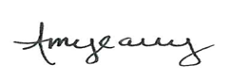

_____________________________________________ _____07/13/2018_____
Quality Control Director Date

