CERTIFICATE OF ANALYSIS

Product Number: | RTE-1000
Description: | Rabbit Thymus tissue extract.
Lot Number: | 5985
Appearance: | Lyophilized Powder

Assays:
Immunodiffusion:
Test | Results (Precipitation)
SSA | Not tested
SSB | Positive
SCL | Positive
Sm | Positive
Sm/RNP | Positive
Jo-1 | Positive
Other: Ribosomal P | Positive

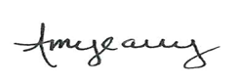
_____________________________________________ ______9/2/2016____
Quality Control Director Date

